

Clear Aligner Therapy at Dental Associates of Grovetown

Invisalign Database Project



February 7, 2021

dental associates of grovetown (Heartland Dental)

9596 Bently Drive, Grovetown, GA 30813

DeAndre Thomas, RDH, BS

Table of Contents

**Summary1**

**Stakeholders2**

**Business Rules2**

**Glossary3**

**Data Questions3**

**Conceptual Model4**

**Logical Model5**

Summary

Dental Associates of Grovetown is a corporate dental office/practice under the dental support organization (DSO) Heartland Dental. This dental practice opened November 2017. Upon opening, the dentists in the practice were allotted the opportunity to learn about orthodontics and how to effectively treat orthodontic issues with clear aligner therapy via Invisalign. Currently, Dental Associates of Grovetown uses Dentrix (dental practice software), which stores data regarding patient information, treatment plans, and financial information. Although the information is stored in the software, it has been difficult tracking those patient’s that have been treatment planned for clear aligner therapy. I intend to implement a database for Dental Associates of Grovetown that will track patients, their insurance, treatment plans, and to identify trends that may be used to increase acceptance of recommended treatment (clear aligner therapy).

In Phase I, I will define the business rules, data glossary, and business questions, which would help identify the entities and relationships within this project. I will also be providing both conceptual and logical models for this database.

Upon review and approval of the stakeholders, we will be able to being Phase II, which is implementation of the database.

Stakeholders

The stakeholders of this project are the regional director of operations (RDO), the regional manager of operations (RMO), practice manager of operations (PMO), Invisalign, who’s parent company is Align Technology, and the employees, patients. I have proposed that the implementation of this database will increase case acceptance of clear aligner therapy, which will increase the profitability of the practice and will have a positive impact on all stakeholders. Patients will have access to their patient records including dates of treatment plan, beginning and end of treatment, patient ledger, insurance information, payment records, office visit dates, and services received on dates. Employees will be able to view the patient’s that are treatment planned for Invisalign. RDO, RMO, and PMO will be able to track profits, number of patients seen, and have an overview of patient’s that have been treatment planned for clear aligner therapy.

Business Rules

* A patient suffers from malocclusion and/or malposition of teeth
* A patient comes into Dental Associates of Grovetown
* A business assistant (employee) obtains patient information
* A patient is scanned by clinical staff (employee)
* A patient is treatment planned for clear aligner therapy by dentist (employee)
* A treatment plan includes treatment costs
* Treatment costs include office fees, insurance fees, estimated insurance coverage, and estimated patient out-of-pocket expense
* A treatment status updates the ledger
* Treatment costs updates the ledger
* Office visit dates update the ledger
* Services received updates the ledger
* Patient payments update the ledger

Glossary

* A **patient** is a person that has been treatment planned for clear aligner therapy
* A **business** **assistant** is employee of Dental Associates of Grovetown
* A **clinician** is an employee of Dental Associates of Grovetown that scans and inputs rendered services
* A **patient’s information** is their name, gender, address, phone number, date of birth, and insurance information
* A **treatment plan** is created by a dentist, that recommends that patient has clear aligner therapy, is by patient prior to beginning treatment, and includes patients name, office fees for service, insurance fees for service, estimated insurance coverage of service, and estimated out-of-pocket expense of patient
* A **clear aligner** **therapy** is Invisalign
* A **treatment status** can be either OPEN, IN, or CLOSED
* An **OPEN** **treatment status** means that patient has not began treatment
* An **IN treatment status** means that patient has began treatment
* A **CLOSED treatment** status means that treatment is complete and patient has balance of $0.00 in ledger
* A **ledger** demonstrates office fees for service, insurance fees for service, estimated insurance coverage of service, patient payments, and dates of service

Data Questions

* How many patients have been treatment planned for Invisalign?
* How many patients have completed Invisalign?
* How many patients are currently in treatment for Invisalign?
* What type of dental insurance do patient have that are in treatment for Invisalign?
* Where do the patients that are in treatment for Invisalign?
* What is the average time that patients are in treatment?

Conceptual Model

Logical Model

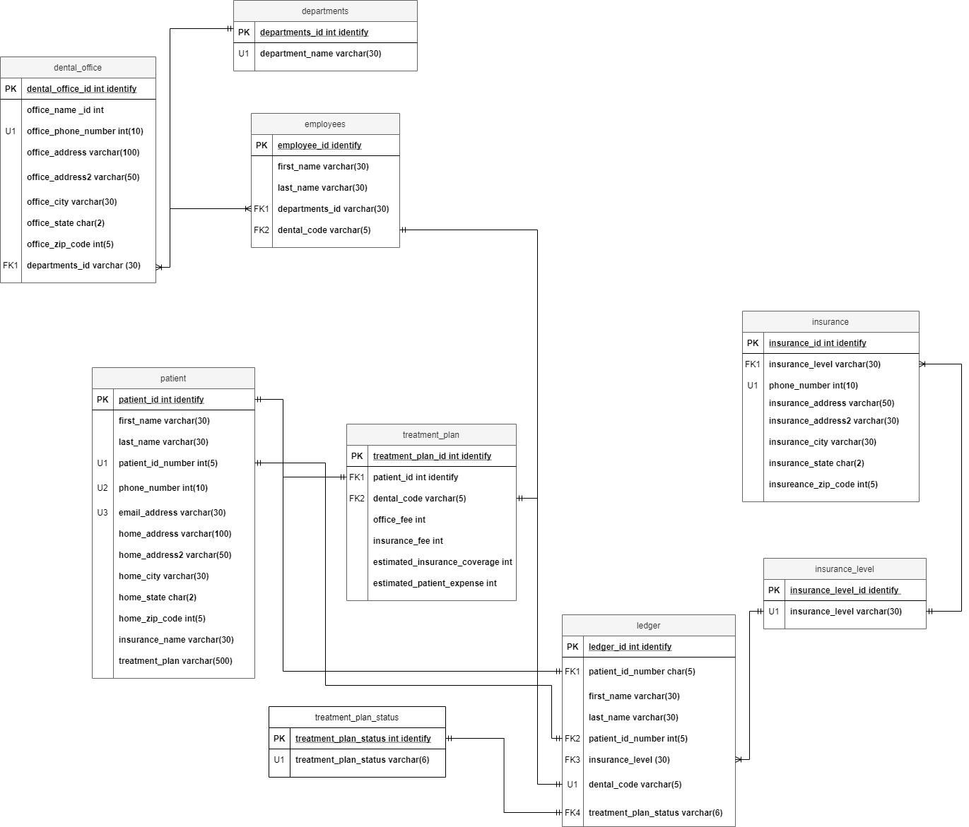

Physical Database Design

--create tables

-- Creating the Patient Table

CREATE TABLE patient(

--create columns

patient_id int identity

, first_name varchar(30) NOT NULL

, last_name varchar(30) NOT NULL

, patient_id_number char(5) NOT NULL

, phone_number char(10) NOT NULL

, email_address varchar(30) NOT NULL

, home_address varchar(100) NOT NULL

, home_address2 varchar(50)

, home_city varchar(30) NOT NULL

, home_state char(2) NOT NULL

, home_zip_code char(5) NOT NULL

, insurance_name varchar(30) NOT NULL

, treatment_plan varchar(500) NOT NULL

-- place constraints

, CONSTRAINT PK_patient PRIMARY KEY(patient_id)

, CONSTRAINT U1_patient UNIQUE(patient_id_number)

, CONSTRAINT U2_patient UNIQUE(phone_number)

, CONSTRAINT U3_patient UNIQUE(email_address)

)

-- Creating Insurance Level

CREATE TABLE insurance_level(

-- create columns

insurance_level_id int identity

, insurance_level varchar(30)

-- place constraints

, CONSTRAINT PK_insurance_level PRIMARY KEY(insurance_level_id)

, CONSTRAINT U1_insurance_level UNIQUE(insurance_level)

)

-- Creating Treatment Plan Status Table

CREATE TABLE treatment_plan_status(

-- create columns

treatment_plan_status_id int identity NOT NULL

, treatment_plan_status varchar(6) NOT NULL

-- place constraints

, CONSTRAINT PK_treatment_plan_status PRIMARY KEY(treatment_plan_status)

, CONSTRAINT U1_treatment_plan_status UNIQUE(treatment_plan_status)

)

-- Creating the Ledger Table

CREATE TABLE ledger(

--cerate columns

ledger_id int identity

, patient_id_number char(5) NOT NULL

, first_name varchar(30) NOT NULL

, last_name varchar(30) NOT NULL

, insurance_level varchar(30) NOT NULL

, dental_code varchar(5) NOT NULL

, treatment_Plan_status varchar(6) NOT NULL

-- place constraints

, CONSTRAINT PK_ledger PRIMARY KEY(ledger_id)

, CONSTRAINT FK1_ledger FOREIGN KEY(patient_id_number) REFERENCES

patient(patient_id_number)

, CONSTRAINT FK2_ledger FOREIGN KEY(patient_id_number) REFERENCES

patient(patient_id_number)

, CONSTRAINT FK3_ledger FOREIGN KEY(insurance_level) REFERENCES

insurance_level(insurance_level)

, CONSTRAINT FK4_ledger FOREIGN KEY(treatment_plan_status) REFERENCES

treatment_plan_status(treatment_plan_status)

, CONSTRAINT U1_ledger UNIQUE(dental_code)

)

-- Creating the Insurance Table

CREATE TABLE insurance(

-- create columns

insurance_id int identity

, insurance_level varchar(30)

, phone_number char(10) NOT NULL

, insurance_address varchar(30) NOT NULL

, insurance_address2 varchar(30)

, insurance_city varchar(30) NOT NULL

, insurance_state char(2) NOT NULL

, insurance_zip_code char(5) NOT NULL

-- place constraints

, CONSTRAINT PK_insurance PRIMARY KEY(insurance_id)

, CONSTRAINT U1_insurance UNIQUE(insurance_level)

, CONSTRAINT U2_insurnace UNIQUE(phone_number)

)

-- Creating Departments Table

CREATE TABLE departments(

-- create columns

departments_id int identity

, departments_name varchar(30) NOT NULL

-- place constraints

, CONSTRAINT PK_departments PRIMARY KEY(departments_id)

, CONSTRAINT U1_departments UNIQUE(departments_name)

)

-- Creating Employees Table

CREATE TABLE employees(

-- create columns

employee_id int identity

, first_name varchar(30) NOT NULL

, last_name varchar(30) NOT NULL

, departments_name varchar(30) NOT NULL

, dental_code varchar(5) NOT NULL

-- place constraints

, CONSTRAINT PK_employees PRIMARY KEY(employee_id)

)

-- Creating Treatment Plan Table

CREATE TABLE treatment_plan(

-- create columns

treatment_plan_id int identity

, patient_id_number char(5)

, dental_code varchar(5) NOT NULL

, office_fee int NOT NULL

, insurance_fee int NOT NULL

, estimated_insruance_coverage int NOT NULL

, estimated_patient_expense int NOT NULL

--place constraints

, CONSTRAINT PK_treatment_plan PRIMARY KEY(treatment_plan_id)

, CONSTRAINT FK1_treatment_plan FOREIGN KEY(patient_id_number) REFERENCES

patient(patient_id_number)

, CONSTRAINT FK2_treatment_plan FOREIGN KEY(dental_code) REFERENCES

ledger(dental_code)

)

-- Creating Dental Office Table

CREATE TABLE dental_office(

-- create columns

dental_office_id int identity

, office_name_id varchar(50) NOT NULL

, office_phone_number char(10) NOT NULL

, office_address varchar(100) NOT NULL

, office_address2 varchar(50)

, office_city varchar(30) NOT NULL

, office_state char(2) NOT NULL

, office_zip_code char(5) NOT NULL

, departments_name varchar(30) NOT NULL

-- place constraints

, CONSTRAINT PK_dental_office PRIMARY KEY(dental_office_id)

, CONSTRAINT FK1_dental_office FOREIGN KEY(departments_name) REFERENCES

departments(departments_name)

, CONSTRAINT U1_dental_office UNIQUE(office_phone_number)

)

-- insert all patient into patient table

INSERT INTO patient(first_name, last_name, patient_id_number, phone_number,

email_address, home_address, home_address2, home_city, home_state, home_zip_code,

insurance_name, treatment_plan)

VALUES ('Hervey', 'Benedek', '12345', '7701821224', 'hbenedek0@hp.com', '19 Sheridan Park', NULL, 'Marietta', 'GA', '30061', 'O Conner-Graham', 'D8090')

, ('Gideon', 'Junes', '23456', '7068087981', 'gjunes1@github.io', '338 Bonner Parkway', NULL, 'Cumming', 'GA', '30130', 'Heathcote and Sons', 'D8090')

, ('Rosetta', 'Nice', '34567', '4045850671', 'rnice2@freewebs.com', '551 Del Mar Court', NULL, 'Atlanta', 'GA', '31196', 'Wyman and Sons', 'D8090')

, ('Myrtie', 'Klais', '45678', '4046985072', 'mklais3@unicef.org', '3 Park Meadow Way', NULL, 'Norcross', 'GA', '30092', 'Schroeder Inc', 'D8090')

, ('Hardy', 'Tithecote', '56789', '7069335757', 'htithecote4@a8.net', '966 Sachtjen Court', NULL, 'Athens', 'GA', '30605', 'Schultz-Cole', 'D8090')

, ('Giles', 'Habens', '67890', '4047694252', 'ghabens5@spiegel.de', '346 Hansons Avenue', NULL, 'Atlanta', 'GA', '30351', 'Treutel-Cremin', 'D8090')

, ('Natassia', 'Levens', '78901', '4042744384', 'nlevens6@bandcamp.com', '5 Pine View Street', NULL, 'Atlanta', 'GA', '30368', 'Runolfsdottir and Sons', 'D8090')

, ('Frazier', 'Hovard', '89012', '4046438751', 'fhovard7@businessinsider.com', '98035 Fair Oaks Drive', NULL, 'Atlanta', 'GA', '31136', 'Sporer-O Keefe', 'D8090')

, ('Sherie', 'Janowski', '90123', '7707886605', 'sjanowski8@army.mil', '0294 Mosinee Junction', NULL, 'Alpharetta', 'GA', '30022', 'Lebsack and Bernier', 'D8090')

, ('Hilton', 'Dyka', '10111', '4789945257', 'hdyka9@weebly.com', '539 Maple Court', NULL, 'Macon', 'GA', '31205', 'Ullrich-Hagenes', 'D8090')

, ('Sara-ann', 'Maffeo', '11234', '4049351585', 'smaffeoa@weather.com', '198 Debs Street', NULL, 'Atlanta', 'GA', '31165', 'Homenick LLC', 'D8090')

, ('Prisca', 'Tennock', '12134', '7708957030', 'ptennockb@tumblr.com', '32424 Badeau Hill', NULL, 'Atlanta', 'GA', '30311', 'OConnell and Witting', 'D8090')

, ('Nicola', 'Folley', '13234', '4042629666', 'nfolleyc@fastcompany.com', '6560 Bayside Drive', NULL, 'Lawrenceville', 'GA', '30245', 'Kuvalis-Jacobson', 'D8090')

, ('Maurine', 'Yurinov', '14234' , '6787989767', 'myurinovd@vinaora.com', '56540 Spaight Parkway', NULL, 'Duluth', 'GA', '30096', 'Fay and Wisoky', 'D8090')

, ('Balduin', 'Despenser', '15432', '4046037898', 'bdespensere@de.vu', '04 Dawn Crossing', NULL, 'Atlanta', 'GA', '30375', 'Ritchie and Stark', 'D8090')

, ('Dixie', 'Eakens', '15678', '4049105044', 'deakensf@imdb.com', '2262 Morning Parkway', NULL, 'Atlanta', 'GA', '31136', 'Schaden Group', 'D8090')

, ('Martie', 'Colton', '16765', '4045198046', 'mcoltong@nydailynews.com', '655 Larry Parkway', NULL, 'Marietta', 'GA', '30066', 'Prohaska, Schmidt and Bergnaum', 'D8090')

, ('Filbert', 'Illes', '17890', '4043403073', 'fillesh@examiner.com', '2879 Anhalt Circle', NULL, 'Lawrenceville', 'GA', '30245', 'Bashirian Inc', 'D8090')

, ('Westbrooke', 'Mollindinia', '18987', '7706441657', 'wmollindiniai@wisc.edu', '3 Haas Parkway', NULL, 'Lawrenceville', 'GA', '30245', 'Boyer, Pfannerstill and Kutch', 'D8090')

, ('Lea', 'Duerden', '19101', '9128818077', 'lduerdenj@fda.gov', '344 Lakeland Plaza', NULL, 'Savannah', 'GA', '31410', 'Rosenbaum and Bergnaum', 'D8090')

, ('Celia', 'Sisson', '20212', '7065730380', 'csissonk@yellowbook.com', '4 Talmadge Parkway', NULL, 'Athens', 'GA', '30605', 'Schumm Inc', 'D8090')

, ('Georgiana', 'Hatcher', '21234', '4788296008', 'ghatcherl@xrea.com', '028 Continental Plaza', NULL, 'Macon', 'GA', '31205', 'Leannon Group', 'D8090')

, ('Zack', 'Mesant', '22343', '6784995896', 'zmesantm@weibo.com', '89 Gina Road', NULL, 'Marietta', 'GA', '30066', 'Kohler-Gleichner', 'D8090')

, ('Flin', 'Brumhead', '29875', '7705744898', 'fbrumheadn@photobucket.com', '792 Lerdahl Alley', NULL, 'Atlanta', 'GA', '30301', 'Braun-Marquardt', 'D8090')

, ('Garvy', 'Myderscough', '24341', '7064989628', 'gmyderscougho@salon.com', '07 Leroy Alley', NULL, 'Columbus', 'GA', '31998', 'Koepp-Friesen', 'D8090')

, ('Filippo', 'Sheere', '25786', '4785503398', 'fsheerep@businessinsider.com', '13139 Londonderry Parkway', NULL, 'Macon', 'GA', '31210', 'O Keefe-Towne', 'D8090')

, ('Daryl', 'Ganniclifft', '26556', '4047013105', 'dganniclifftq@tuttocitta.it', '55 Memorial Hill', NULL, 'Atlanta', 'GA', '30301', 'Nienow LLC', 'D8090')

, ('Siobhan', 'Ruckhard', '27909', '4043348499', 'sruckhardr@tripadvisor.com', '4469 Hauk Hill', NULL, 'Atlanta', 'GA', '30368', 'Powlowski-Sauer', 'D8090')

, ('Wit', 'Braams', '28123', '9123873510', 'wbraamss@amazon.co.uk', '4559 Schurz Trail', NULL, 'Savannah', 'GA', '31422', 'Beahan-Padberg', 'D8090')

, ('Randy', 'Nathon', '29325', '4788351160', 'rnathont@wordpress.com', '54407 Nova Plaza', NULL, 'Macon', 'GA', '31210', 'Metz and Sons', 'D8090')

, ('Quentin', 'Beneteau', '30567', '4045575337', 'qbeneteauu@rambler.ru', '861 Browning Avenue', NULL, 'Atlanta', 'GA', '30328', 'Runolfsdottir', 'D8090')

, ('Jada', 'MacCartan', '31768', '4048107082', 'jmaccartanv@fotki.com', '159 Waxwing Trail', NULL, 'Duluth', 'GA', '30195', 'Bernhard and Quitzon', 'D8090')

, ('Branden', 'Comberbeach', '32334', '7701914353', 'bcomberbeachw@bandcamp.com', '56435 Colorado Junction', NULL, 'Atlanta', 'GA', '30301', 'Rogahn, Kozey and McLaughlin', 'D8090')

, ('Justis', 'Tolcharde', '33546', '6784651624', 'jtolchardex@psu.edu', '0470 Golf Course Park', NULL, 'Norcross', 'GA', '30092', 'Johns Group', 'D8090')

, ('Francis', 'Jeskin', '34786', '9128014760', 'fjeskiny@indiatimes.com', '79801 Dwight Pass', NULL, 'Savannah', 'GA', '31422', 'Carroll-Kemmer', 'D8090')

, ('Valenka', 'Megarrell', '35234', '7066852964', 'vmegarrellz@devhub.com', '19657 Parkside Terrace', NULL, 'Columbus', 'GA', '31998', 'Renner-Towne', 'D8090')

, ('Hans', 'Halfpenny', '36776', '4041099233', 'hhalfpenny10@npr.org', '85 Butterfield Drive', NULL, 'Atlanta', 'GA', '30351', 'Ankunding and Waters', 'D8090')

, ('Phaedra', 'Glasby', '37688', '4786697128', 'pglasby11@tiny.cc', '621 Prairieview Drive', NULL, 'Macon', 'GA', '31217', 'Satterfield and Sons', 'D8090')

, ('Claresta', 'Bonnin', '38989', '4045130693', 'cbonnin12@fda.gov', '90057 Eagan Way', NULL, 'Atlanta', 'GA', '30306', 'Boyle and Adams', 'D8090')

, ('Neal', 'Penton', '39765', '4042572269', 'npenton13@altervista.org', '2 Bashford Drive', NULL, 'Atlanta', 'GA', '31136', 'Langworth and Botsford', 'D8090')

, ('Johnathon', 'Gregersen', '40745', '9121298338', 'jgregersen14@imgur.com', '24741 Twin Pines Drive', NULL, 'Savannah', 'GA', '31405', 'Hegmann Group', 'D8090')

, ('Arlen', 'Challin', '41654', '4044756112', 'achallin15@usnews.com', '077 Manley Point', NULL, 'Atlanta', 'GA', '30343', 'Adams LLC', 'D8090')

, ('Leisha', 'MacMillan', '42356', '4043162179', 'lmacmillan16@google.it', '34944 Aberg Avenue', NULL, 'Atlanta', 'GA', '30340', 'Altenwerand', 'D8090')

, ('Maynord', 'Costy', '43787', '7061877642', 'mcosty17@photobucket.com', '59 Golf Road', NULL, 'Athens', 'GA', '30610', 'Conn-Gulgowski', 'D8090')

, ('Lila', 'Haisell', '44876', '7062245978', 'lhaisell18@blinklist.com', '9294 Oakridge Avenue', NULL, 'Athens', 'GA', '30605', 'Dare Thiel', 'D8090')

, ('Andi', 'Pesic', '45454', '9121398980', 'apesic19@google.it', '61 Straubel Parkway', NULL, 'Macon', 'GA', '31217', 'Steuber-Homenick', 'D8090')

, ('Sharyl', 'Pridie', '46659', '4787287439', 'spridie1a@dropbox.com', '22193 Golf Course Parkway', NULL, 'Macon', 'GA', '31296', 'Medhurst-Veum', 'D8090')

, ('Loree', 'Molineaux', '47098', '7062424496', 'lmolineaux1b@netscape.com', '6 Autumn Leaf Terrace', NULL, 'Columbus', 'GA', '31904', 'Osinski DuBuque', 'D8090')

, ('Berti', 'Dunphy', '48985', '7062739418', 'bdunphy1c@cargocollective.com', '50565 Texas Trail', NULL, 'Cumming', 'GA', '30130', 'Bradtke Inc', 'D8090')

, ('Colette', 'Furtado', '49650', '7708845166', 'cfurtado1d@purevolume.com', '01 Green Ridge Court', NULL, 'Atlanta', 'GA', '30316', 'Wiza and Hessel', 'D8090')

-- Viewing Patient Table

SELECT * FROM patient

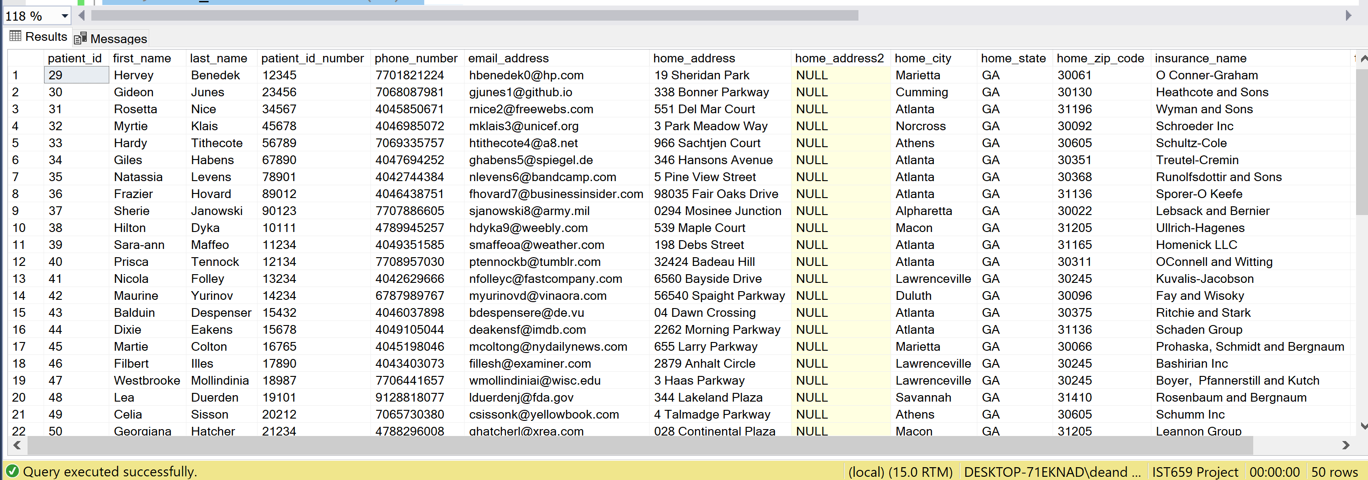

-- insert all employees into employee table

INSERT INTO employees(first_name, last_name, departments_name, dental_code)

VALUES ('Danielle', 'Owen', 'Dentist', 'D8090')

, ('Kristen', 'Green', 'Dentist', 'D8090')

, ('Alexis', 'Williams', 'Assistant', 'D8090')

, ('Jessi', 'Marchman', 'Assistant', 'D8090')

, ('Rie', 'Wilson', 'Assistant', 'D8090')

, ('Chasity', 'Jeffery', 'Assistant', 'D8090')

, ('Quett', 'Cooper', 'Hygienist', 'D8090')

, ('Christina', 'Leonard', 'Hygienist', 'D8090')

, ('DeAndre', 'Thomas', 'Hygienist', 'D8090')

-- Viewing Employee Table

SELECT * FROM employees

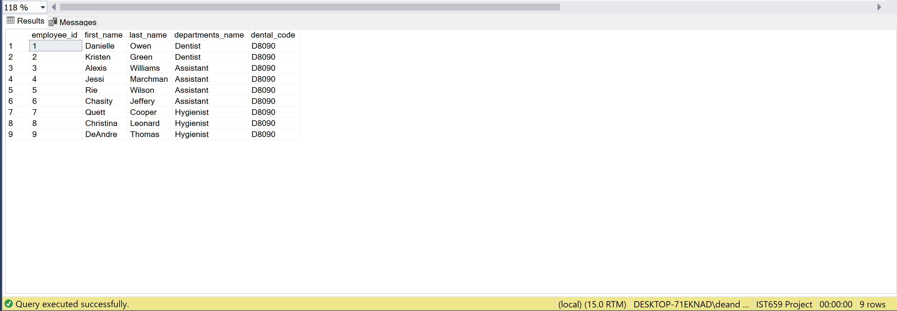

--insert all insurance data into insurance table

INSERT INTO insurance(insurance_level, phone_number, insurance_address, insurance_address2

, insurance_city, insurance_state, insurance_zip_code)

VALUES ('O Conner-Graham', '8394526696', '45050 Nancy Park', NULL, 'Athens', 'GA', '30605')

, ('Heathcote and Sons', '7644026731','9399 Fisk Court', NULL,'Duluth','GA','30195')

, ('Wyman and Sons', '4753273435','481 Prairieview Parkway', NULL,'Atlanta','GA','31119')

, ('Schroeder Inc', '1346469471','9399 Lien Drive', NULL,'Savannah','GA','31422')

, ('Treutel-Cremin', '3985290867','41 North Junction', NULL,'Lawrenceville','GA','30045')

, ('Runolfsdottir and Sons', '4418701013','6198 Sage Park', NULL,'Macon','GA','31296')

, ('Sporer-O Keefe', '1267555551','8 5th Pass', NULL,'Augusta','GA','30919')

, ('Lebsack and Bernier','4605246025','8290 Havey Hill', NULL,'Macon','GA','31296')

, ('Ullrich-Hagenes', '4596687235','01 Clarendon Alley', NULL,'Atlanta','GA','30340')

, ('Homenick LLC', '3316647439','918 North Place', NULL,'Atlanta','GA','30380')

, ('OConnell and Witting', '5189310036','619 Iowa Park', NULL,'Atlanta','GA','31132')

, ('Kuvalis-Jacobson','4765646845','2437 Briar Crest Junction', Null,'Atlanta','GA','30306')

, ('Fay and Wisoky', '1653074565','30364 Farwell Alley', NULL,'Savannah','GA','31410')

, ('Ritchie and Stark', '4337747454','8 Starling Circle', NULL,'Lawrenceville','GA','30045')

, ('Schaden Group', '3036718732','06 Mallard Circle', NULL,'Atlanta','GA','31190')

, ('Prohaska, Schmidt and Berg','5082122086','1 Bonner Hill', NULL,'Lawrenceville','GA','30245')

, ('Bashirian Inc', '9596177910','5 Manufacturers Point', NULL,'Atlanta','GA','30306')

, ('Boyer, Pfannerstill and Kutch', '8946472325','2226 Talisman Pass', NULL, 'Atlanta','GA','30328')

, ('Rosenbaum and Bergnaum', '9228400563','2921 Independence Terrace', NULL, 'Augusta','GA','30911')

, ('Schumm Inc','1315740326','87624 Porter Parkway', NULL,'Lawrenceville','GA','30245')

, ('Leannon Group', '3065765490','56961 Golden Leaf Place', NULL,'Atlanta','GA','30301')

, ('Kohler-Gleichner', '6362465094','6857 Michigan Crossing', NULL, 'Atlanta','GA','30351')

, ('Braun-Marquardt', '2379576688','221 Petterle Lane', NULL,'Atlanta','GA','30316')

, ('Koepp-Friesen', '5505821809','3699 Claremont Hill', NULL,'Atlanta','GA','30311')

, ('O Keefe-Towne','8666568828','8783 Sage Drive', NULL,'Atlanta','GA','30358')

, ('Nienow LLC', '9691241140','85663 Surrey Drive', NULL,'Alpharetta','GA','30022')

, ('Powlowski-Sauer', '3899076544','74140 Goodland Road', NULL,'Lawrenceville','GA','30245')

, ('Beahan-Padberg', '7361357591','961 Gina Circle', NULL,'Atlanta','GA','30343')

, ('Metz and Sons', '1295379237','1634 Tony Hill', NULL, 'Decatur','GA','30033')

, ('Runolfsdottir', '6247384206','10 Vera Alley', NULL,'Atlanta','GA','30340')

, ('Bernhard and Quitzon', '2737135805','24444 Carioca Trail', NULL,'Savannah','GA','31405')

, ('Rogahn, Kozey and McLaughlin', '8924135336','14557 Bartelt Pass', NULL,'Duluth','GA','30096')

, ('Johns Group', '5997914793','598 Old Shore Lane', NULL,'Augusta','GA','30919')

, ('Carroll-Kemmer', '2235912983','3 Warrior Crossing', NULL,'Athens','GA','30605')

, ('Renner-Towne', '4093284239','1699 Division Avenue', NULL,'Columbus','GA','31904')

, ('Ankunding and Waters', '6055057830','810 New Castle Avenue', NULL,'Atlanta','GA','30323')

, ('Satterfield and Sons', '4887873918','559 Arizona Parkway', NULL,'Atlanta','GA','31190')

, ('Boyle and Adams', '4978187796','1896 Randy Trail', NULL,'Macon','GA','31296')

, ('Langworth and Botsford', '2357843728','80 Eastwood Point', NULL,'Atlanta','GA','31190')

, ('Hegmann Group', '2194504513','1690 2nd Lane', NULL,'Atlanta','GA','31119')

, ('Adams LLC', '2725640570','18 Fisk Alley', NULL,'Atlanta','GA','30358')

, ('Altenwerand', '2141022218','13686 Algoma Center', NULL,'Atlanta','GA','31190')

, ('Conn-Gulgowski', '4105059373','224 Memorial Circle', NULL,'Columbus','GA','31904')

, ('Dare Thiel', '2136072810','06 Aberg Place', NULL,'Atlanta','GA','30392')

, ('Steuber-Homenick', '6768439533','4 Old Shore Way', NULL,'Atlanta','GA','30356')

, ('Medhurst-Veum','9855840054','567 Boyd Road', NULL,'Atlanta','GA','30343')

, ('Bradtke Inc', '7558471655','9231 Iowa Point', NULL,'Atlanta','GA','30336')

, ('Osinski DuBuque', '1172792234','1594 Express Pass', NULL,'Macon','GA','31296')

, ('Wiza and Hessel', '9722600273', '91 Merry Circle', NULL,'Atlanta','GA','30358')

, ('Schultz-Cole', '5436282160','08 Laurel Circle', NULL,'Atlanta','GA','30358')

-- create view of patient and their treatment plan

GO

CREATE VIEW PatientandTreatmentPlan

AS

SELECT

patient.patient_id_number AS PatientIDNumber,

patient.first_name + ' ' + patient.last_name as PatientName

FROM patient

JOIN treatment_plan ON patient.patient_id_number = treatment_plan.patient_id_number

GO

SELECT*FROM PatientandTreatmentPlan

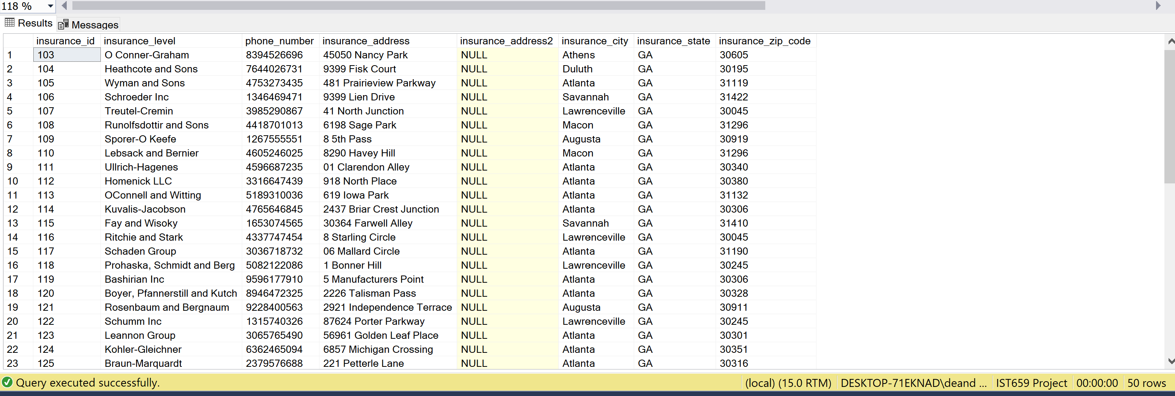

--create view of patient and employee

GO

CREATE VIEW PatientandEmployee

AS

SELECT

patient.treatment_plan AS TreatmentPlan,

patient.first_name + ' ' + patient.last_name as PatientName

FROM patient

RIGHT JOIN employees ON patient.treatment_plan = employees.dental_code

GO

SELECT*FROM PatientandEmployee